
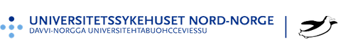


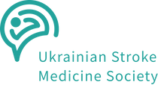 Department to Department: Norway 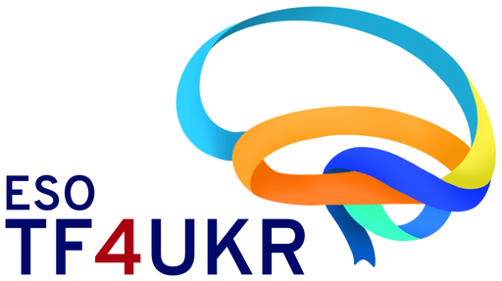 Visiting Programme Ukraine Edition 2024

Norwegian Neuroscience Society

Application Form

Applicant name: Your institution: City:
Co-applicant
(nurse for doctors and vice versa):

Anticipated beginning/end of the programme:
(Minimum 1 week)

Applicant email address:

Documents to be enclosed with the Application Form

- Letter of recommendation from the supervisor or head of your department
- Personal letter of motivation (½ page)
- CV in English (1-2 pages)

Deadline for submission: 30 June 2024

